Property Investor form 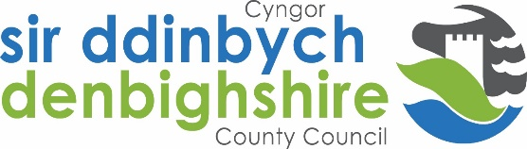
Bringing empty homes back into use is a priority identified in Denbighshire County Council’s Corporate Plan (2017).
Denbighshire County Council (DCC) is setting up a matching service as a pilot project to match empty homes owners with potential investors/landlords.
The purpose of this form is to allow potential investors/landlords to provide details of the property that they are interested in so they can be matched with potential empty home owners. For this information to be passed to the relevant parties any investor/landlord must provide specific permission as stipulated in the Data Protection legislation.
- What area/s of Denbighshire are you willing to consider?
Specific area/s (please specify)

Any area of Denbighshire

- What type of properties are you interested in? Please tick the appropriate options
Type of property | Please tick the appropriate options
Houses
Bungalows
Flats
Other (please specify type)

Any type of empty properties

- Where did you hear about the Empty Homes Matching Scheme? Any other relevant information?

- Please provide your preferred contact details below. This information will be passed onto empty home owners once permission has been granted by signing this form.
Name: ____________________________________
Email address: _________________________________________
Contact telephone number: ________________________________________
I have read this form and fully agree to allow Denbighshire County Council to pass my contact details to empty home owners in order to facilitate a potential deal.
I have read and understand that the above and agree to allow Denbighshire County Council to pass my contact details to potential investors through this scheme.
PLEASE REMEMBER TO SIGN THE FORM – PAGE 2

Any person data you provide will be processed by Denbighshire County Council in accordance with Data Protection Regulation. For further information about this and your rights, please visit our website – www.denbighshire.gov.uk Any person data sent to a third party will be for be processed for the purpose of bringing back empty homes into use only.
Disclaimer: By providing your personal details to Denbighshire County Council you are consenting to Denbighshire County Council to contact you with information about empty properties that fit within your stated criteria. If you decide to make contact with the owner of the empty property you will consent to us providing the empty property owner with your contact details. Please note that Denbighshire County Council is providing an information service only about properties and/or persons who may be interested in selling or buying these properties. This does not amount to a recommendation by Denbighshire County Council that these properties are suitable for your needs. The Council will not seek to verify the accuracy of any property information that has been provided and will accept no responsibility for any inaccuracies or omissions. No communication to you from the Council shall constitute or be deemed to constitute the provision of legal advice. You should take independent legal advice on the purchase/sale of properties to ensure that the necessary checks and safeguards are followed to protect your investment.

Signed: _______________________________ Name: ________________________________________

Please return this form to:

strategichousing@denbighshire.gov.uk

