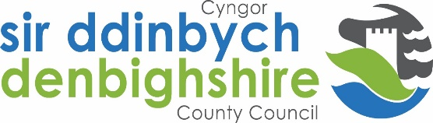
Empty Home owner – information form
Bringing empty homes back into use is a priority for Denbighshire County Council (DCC).
DCC is piloting a service to match empty homes owners with potential investors/landlords.
The purpose of this form is to allow empty home owners to provide details of the property that they wish to sell to link with investor/landlords that could bring it back into use. This form provides permission for the information provided to be passed to the relevant investors/landlords as required by Data Protection legislation.
- What kind of property is the empty home/s (please tick):
House
Bungalow
Flat
Other (please specify) ______________________

- What is the address of the empty home/s and how many bedrooms does it have?

- How long has the home been empty for to the best of your knowledge:

- How did you hear about the Empty Homes Matching Service?

- Any other relevant information – please specify

Please remember to sign the disclaimer on page 2

- Please provide your preferred contact details below. This information will be passed onto empty home owners once permission has been granted.
Name: ____________________________________
Email address: _______________________________________
Contact telephone number: _____________________________________
I have read and understand that the above and agree to allow Denbighshire County Council to pass my contact details to an investor/landlord match through this scheme.
Any person data you provide will be processed by Denbighshire County Council in accordance with Data Protection Regulation. For further information about this and your rights, please visit our website – www.denbighshire.gov.uk Any person data sent to a third party will be for be processed for the purpose of bringing back empty homes into use only.
Disclaimer: By providing your personal details to Denbighshire County Council you are consenting to Denbighshire County Council to advertising your property/properties to people who may be interested in purchasing it. Please note that Denbighshire County Council is providing an information service only about properties and/or persons who may be interested in selling or buying these properties. This does not amount to a recommendation from Denbighshire County Council that these properties are suitable for your needs. You should take independent legal advice on the purchase/sale of properties to ensure that the necessary checks and safeguards are followed to protect your investment.
Signed: ____________________________

Name (please print): ___________________________________

Please return this form to:

strategichousing@denbighshire.gov.uk

