Denbighshire County Council Logo

# How to Enter Return to Work Interview Completion in iTrent Electric

1. Open iTrent Electric
2. Click on People in your main menu.

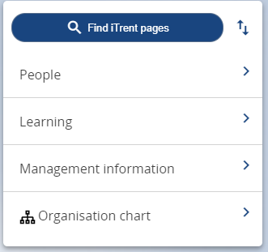

1. Select the employee from your list of reporting employees or by searching for the employee (as shown in the following image).

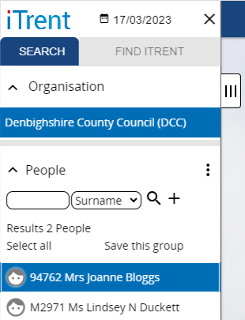

The person summary card will display.

1. Click on the Sickness Absence folder in the LINKS section of the person summary card (the LINKS section is at the bottom).
2. Click on “Absence stage details (sickness) - New”

You will be prompted to select the sickness absence which the employee has returned from in the Sickness Absence List in the menu on the left of the screen.

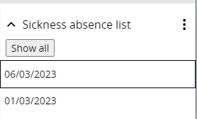

1. Select the sickness absence by clicking on the date in the list.

Please note if you want to view further details of the absence you can click on the ‘Expand sidepane’ tab which appears as three vertical lines on the edge of the menu.

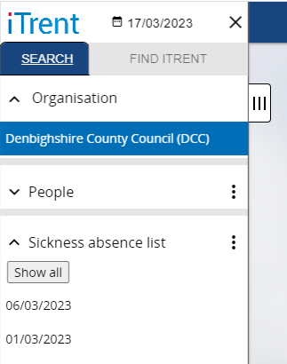

The Absence stage details form opens as follows:

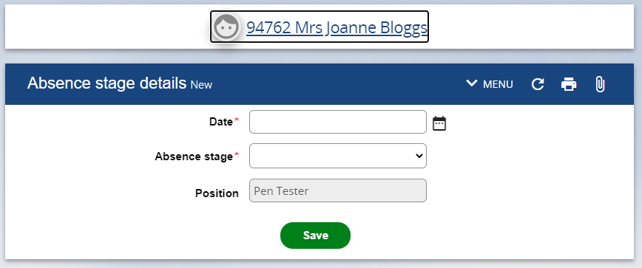

1. Enter the absence stage date DD/MM/YY or select from calendar button
2. Select the Absence stage type from the dropdown menu e.g. Return to Work Interview Form
3. Click on Save