Denbighshire County Council Logo

# How to Check an Employee Working Pattern in iTrent Electric

1. Open iTrent Electric
2. Click on People in your main menu.

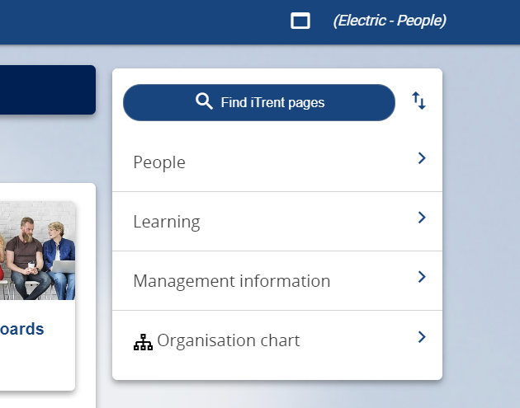

1. Select the employee from your list of reporting employees or by searching for the employee (as shown in the following image).

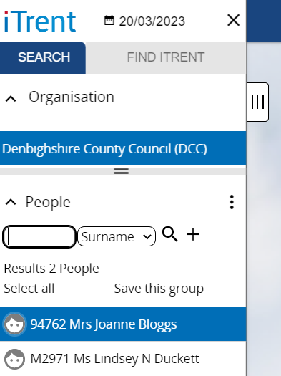

The person summary card will display and there are two ways to get to this information:

## Option 1

1. Click on the Position name (in bold) in the Employment section. 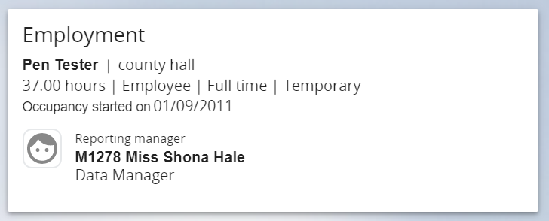

The Position details screen is displayed as follows:

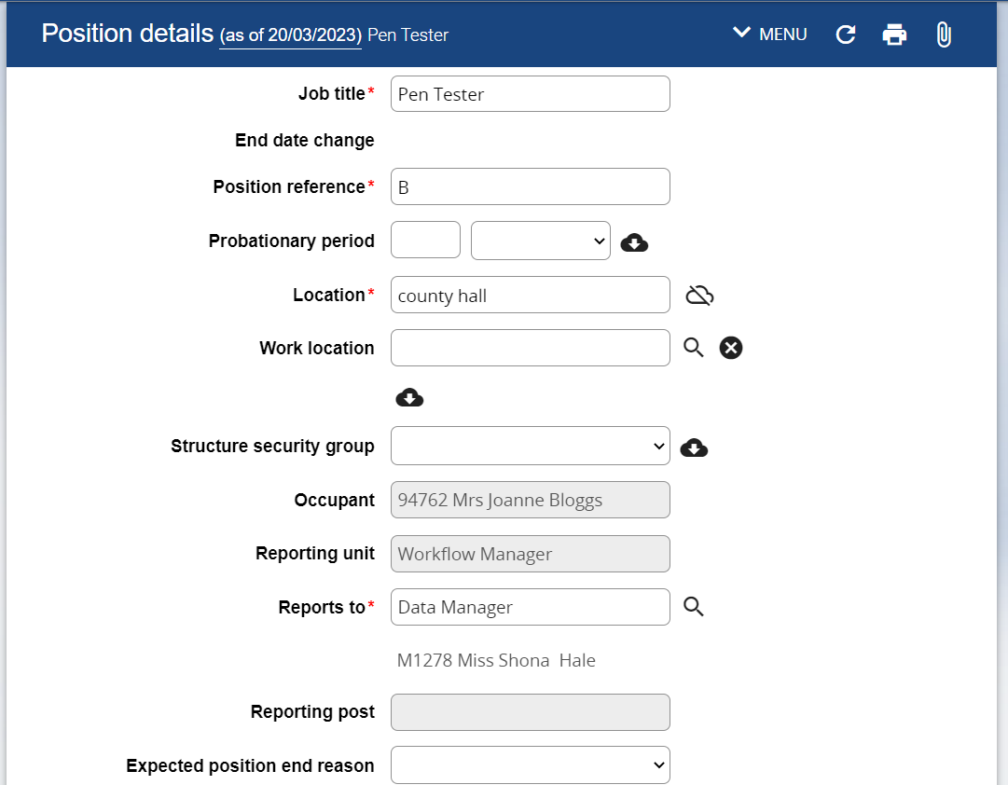

1. Click on the down arrow to the left of MENU in the Position details form header.



The Menu expands as follows:

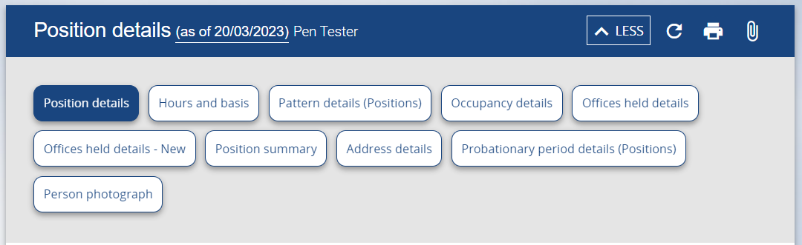

1. Click on Pattern details (Positions)

The Pattern details form opens as follows:

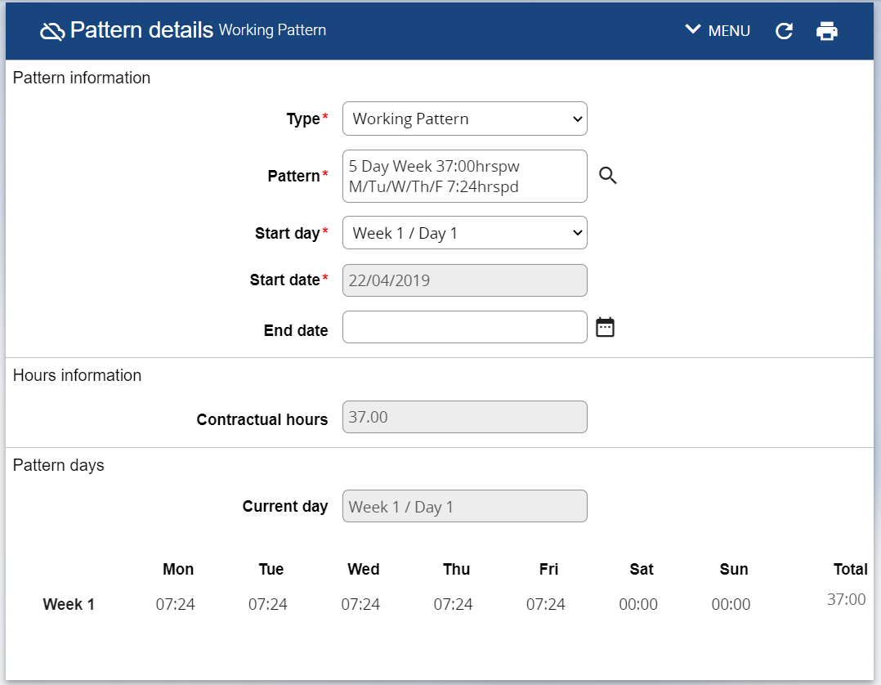

If the employee has multiple patterns please ensure the current pattern is selected in the left hand menu (this will be the one with the blank end date).

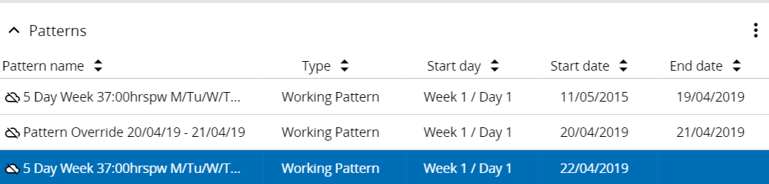

If the working pattern is incorrect please contact Human Resources.

## Option 2

1. Click on the Employment folder in the LINKS section of the person summary card (the LINKS section is at the bottom).
2. Click on Pattern details (Positions).
3. To return to the Employee Summary Card please click on the employee name at the top of the screen.

