Denbighshire County Council Logo

# How to Check Employee Contractual Hours and Basis in iTrent Electric

1. Open iTrent Electric
2. Click on People in your links menu.

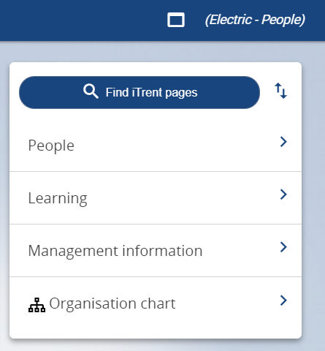

1. Select the employee from your list of reporting employees or by searching for the employee (as shown in the following image).

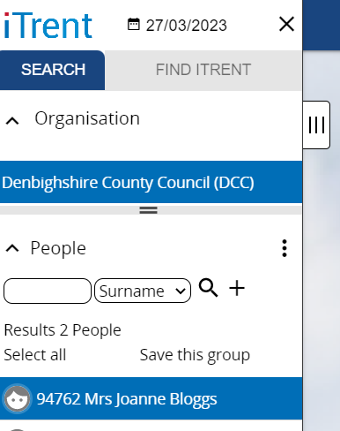

The person summary card will display and the Employment section shows the current contractual hours.

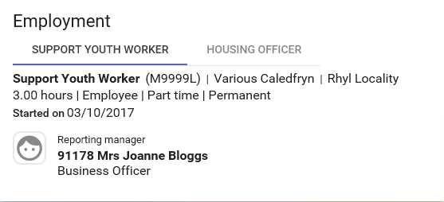

If the employee has multiple roles click on the position name to display the details for each position.

1. Click on the hours line within the employment section to view further contractual information

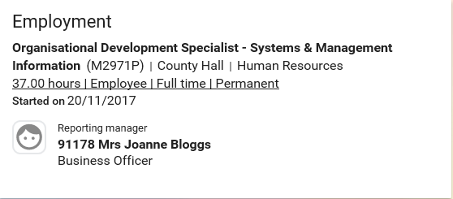

The ‘Hours and basis’ form displays as follows:

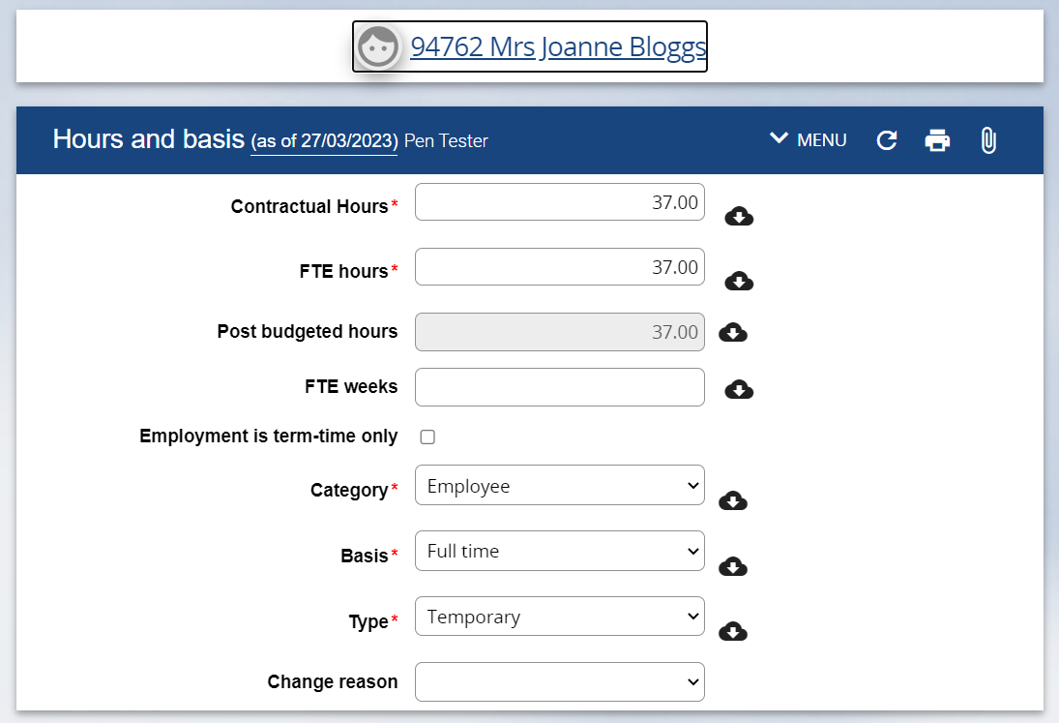

If the hours and basis information is incorrect please contact Human Resources.

1. To return to the Employee Summary Card please click on the employee name at the top of the screen.

