Denbighshire County Council Logo

# Enter Completed Mandatory Learning Details

1. Open iTrent Electric
2. Click on People in your main menu.

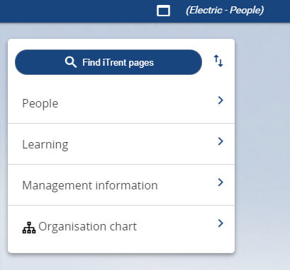

1. Select the employee from your list of reporting employees or by searching for the employee (as shown in the following image).

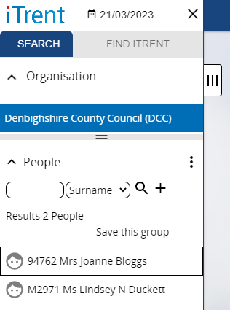

The person summary card will display.

1. Click on the Profile folder in the LINKS section of the person summary card (the LINKS section is at the bottom).

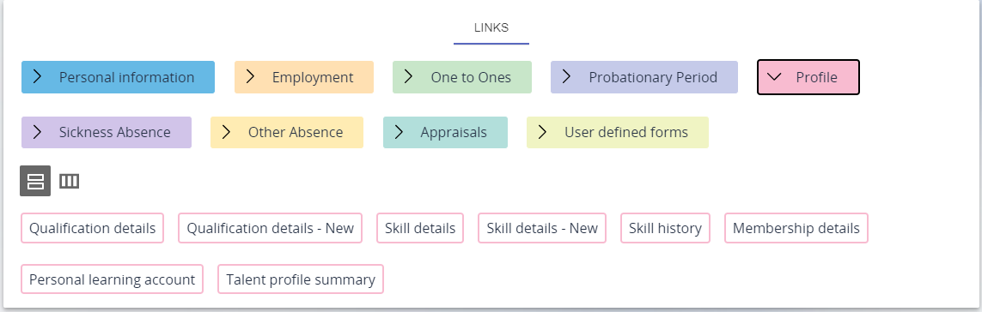

1. Click on “Skill details - New”

Please note if an employee has completed mandatory learning modules they will now be shown in the main menu on the left.

The form opens as shown in the following image.

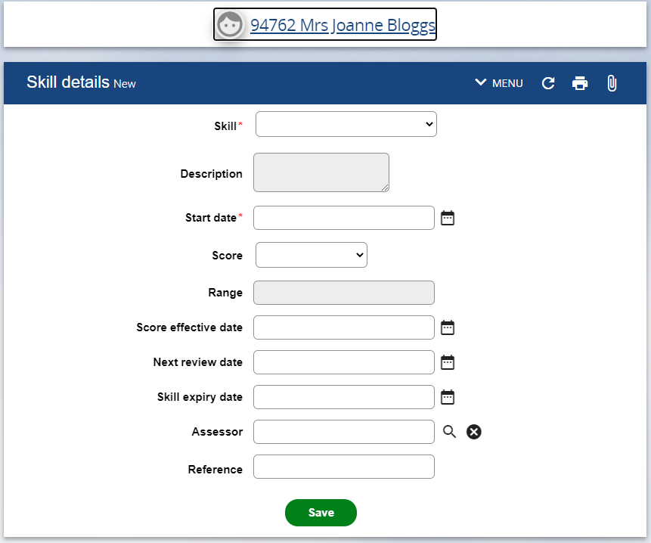

1. Select the mandatory learning module from the Skill dropdown list

The description field will automatically populate.

1. Enter the start date (when the module was started)
2. Enter a score:

1 = Completed Online

2 = Completed Offline

0 = Not Completed

1. Enter the score effective date (when the module was completed – this can be the same as the start date.)
2. Click on Save

