Denbighshire County Council Logo

# How to Change Your Password or Memorable Information and use ‘Forgotten Password?’

This guide will show you how to change your password, enter or change your memorable information and what to do if you have forgotten your password.

## Change Your Password

1. Log in to iTrent
2. **If** requested to select a role choose Electric – People or Electric – Structure.
3. Click on the Personal Menu Icon (face) and select ‘Change my password’.

The change my password form will open:

1. Enter your current password
2. Enter a new password (must be at least 8 characters long and contain both alpha and numeric characters)
3. Confirm the new password
4. Save

## Change Your Memorable Information

1. Log in to iTrent
2. **If** requested to select a role choose Electric – People or Electric – Structure.
3. Click on the Personal Menu Icon (face) and select ‘Memorable information details’.

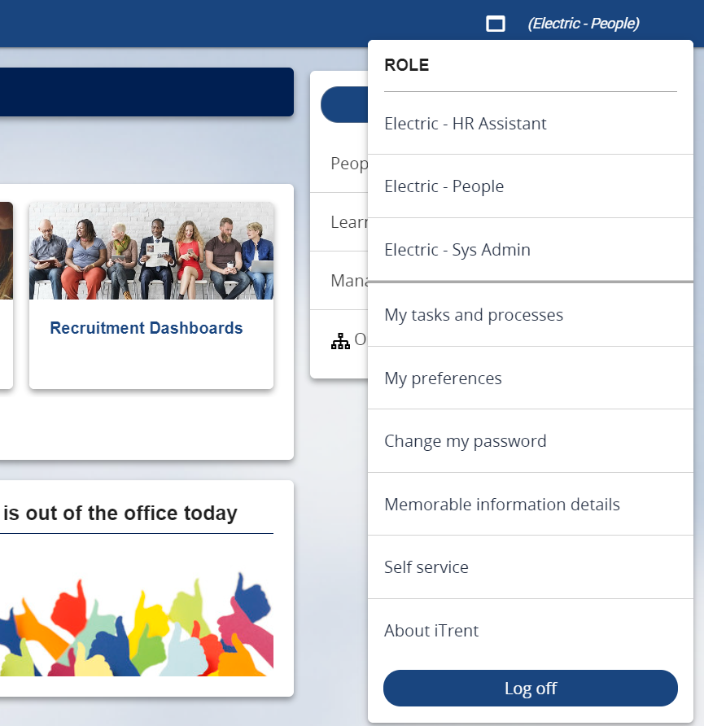

The ‘memorable information details’ form will open:

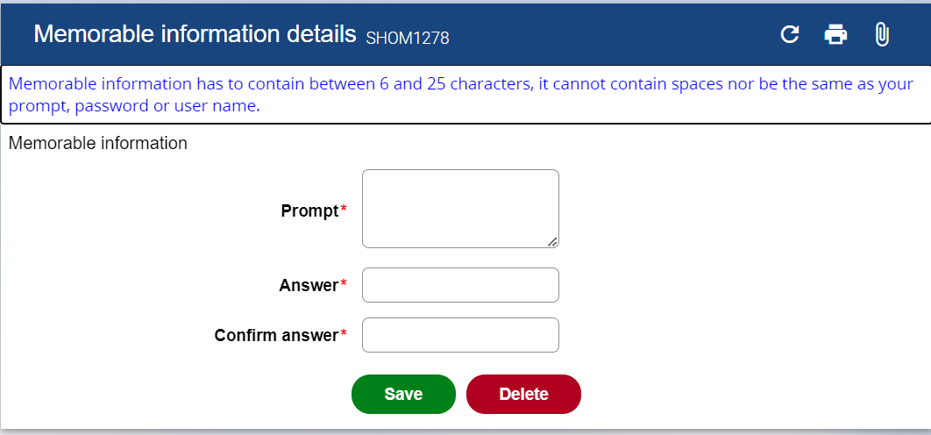

1. Enter a prompt to remind you of the memorable information answer
2. Enter the answer (must be between 6 and 25 characters without spaces and not be the same as the prompt or your password or user name.)
3. Confirm the answer
4. Save

## Forgotten Your Password?

1. Go to the iTrent Electric Login screen and click on Forgotten password?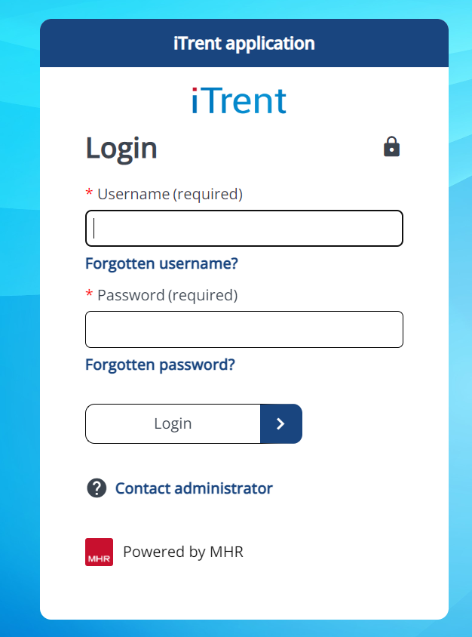
2. Go to the iTrent Electric Login screen and click on Forgotten password?

The ‘Forgotten password’ screen opens:

1. Enter your user name and your prompt will appear:

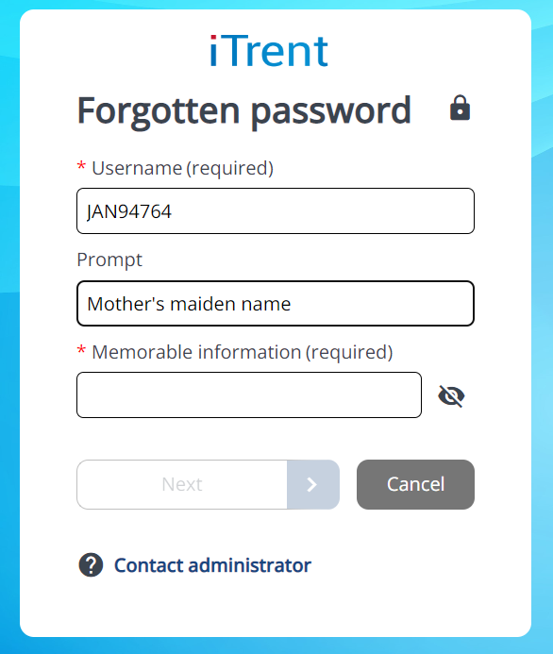

1. Enter your memorable information answer and you will be prompted to change your password.
2. Enter a new password (must be at least 8 characters long and contain both alpha and numeric characters)
3. Confirm password
4. Select ‘Login’.