Denbighshire County Council Logo

# Tasks in ‘My to Do List’

When an employee enters Qualification Details or Membership Details in iTrent Employee Self Service you will receive an email notification to review the details.

To authorise, reject or hold:

1. Open iTrent Electric
2. Click on “My to do list”



1. Click on “Requires an authorisation” to view the details for the qualification or membership that needs attention. 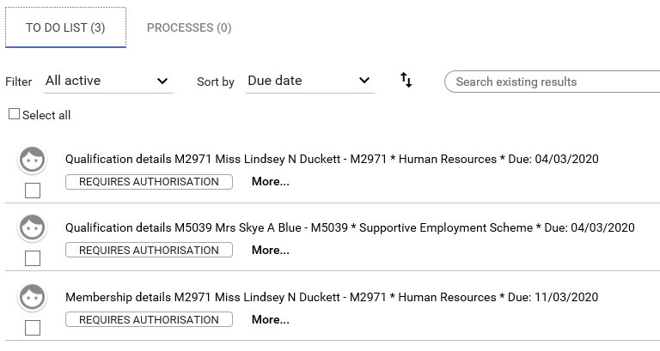

The qualification or membership form opens to view the details:

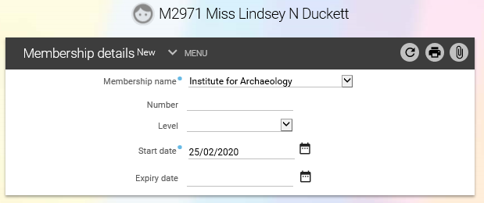

1. To authorise or reject the information navigate back to ‘My to Do List’ by clicking on the crumbtrail (<To do list) to the left of the employee name above the form:

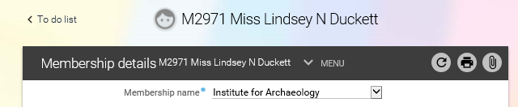

1. Select the row you want to authorise by ticking the box on the left of the details:

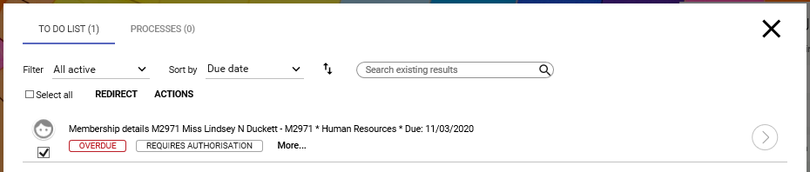

1. The ACTIONS button appears and when you click on it you have the option to select; Authorised, Not authorised, On Hold or Rejected

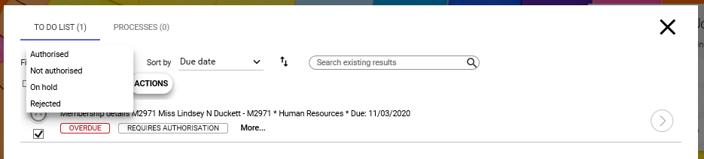

1. Select the appropriate option.
2. Close the ‘To Do List’ by clicking on the cross in the top right corner.

