Denbighshire County Council Logo

# Running Reports

1. Open iTrent Electric
2. Click on Management information in your links menu.

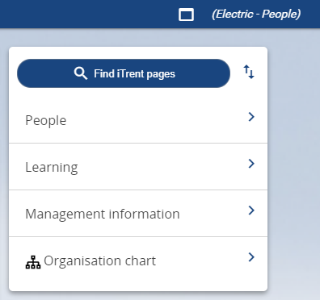

1. Select a report in the Main menu on the left which opens automatically and displays the options within the Absence Reports folder.

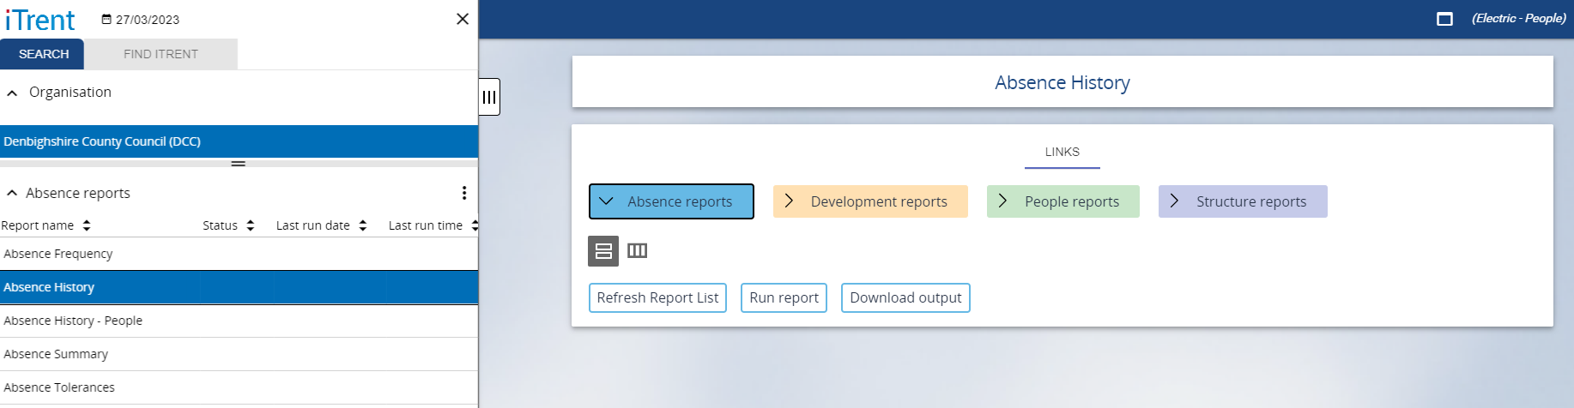

Please note if you want to run a different type of report such as a ‘People’ report when you navigate to the People Reports folder you must click on ‘show report list’ in order to refresh the options in the section.

1. Click on Run report and the Report criteria screen displays:

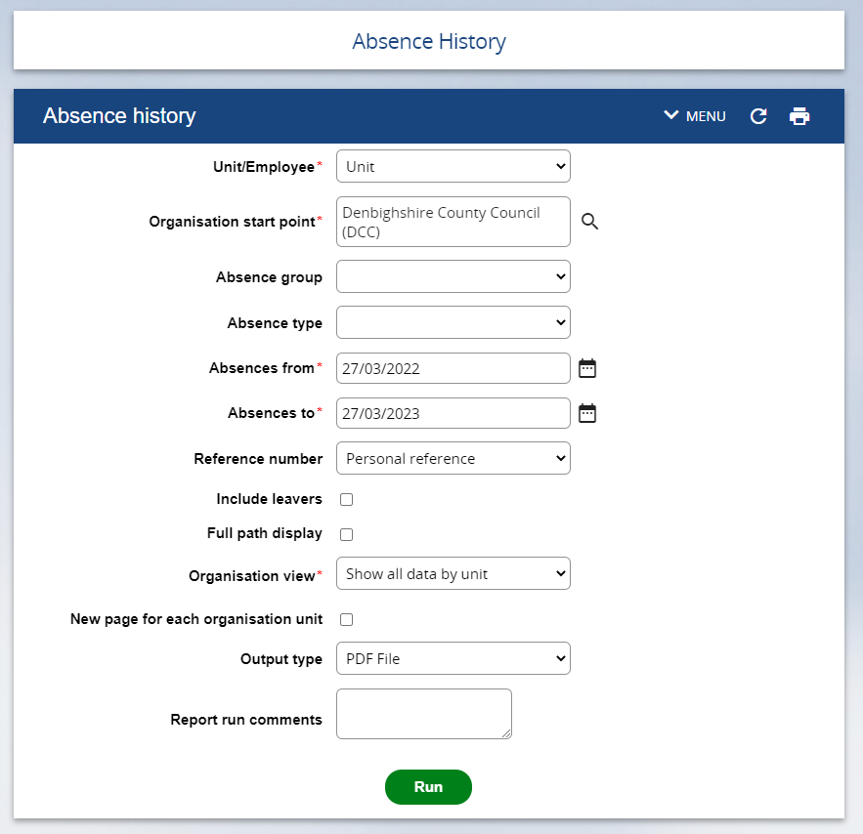

1. Edit the report criteria as required
2. Click Run

The Generating report message will appear above the criteria form:



When the report has run a banner message with alert bell icon will appear across the top:

banner message 

1. You then have two options to access the report output.
2. If you are still in the Run Report Screen click on the Section Menu drop down:

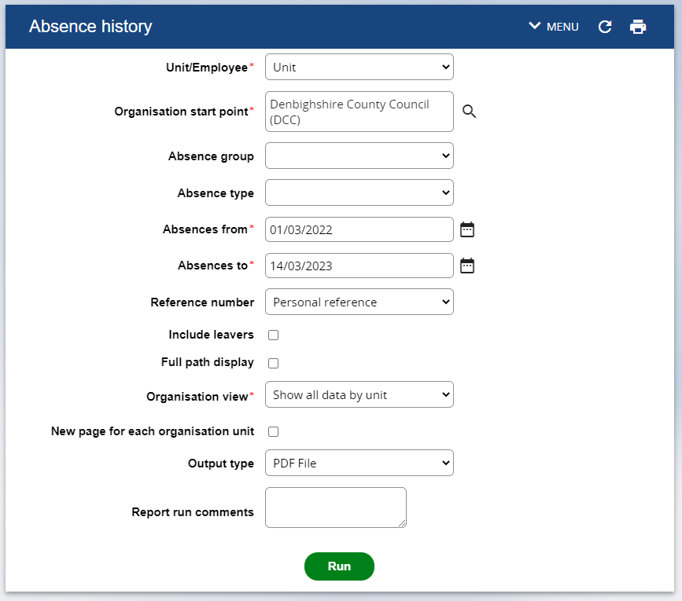

Select Download Output

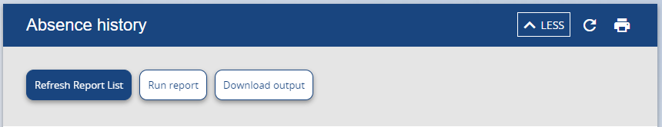

or

1. If you have moved to other screens then go to the Home Page by clicking on the iTrent home button.

iTrent home button

Click on Processes:

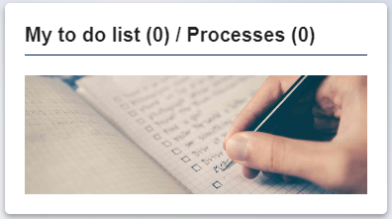

There will be a list of any reports you have run click on the right arrow to the right of the report you want to download.

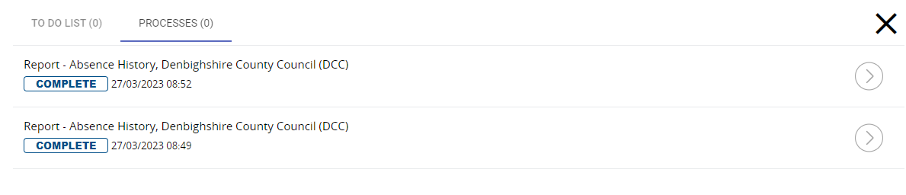

1. Click on the Download button (Down arrow with underscore)

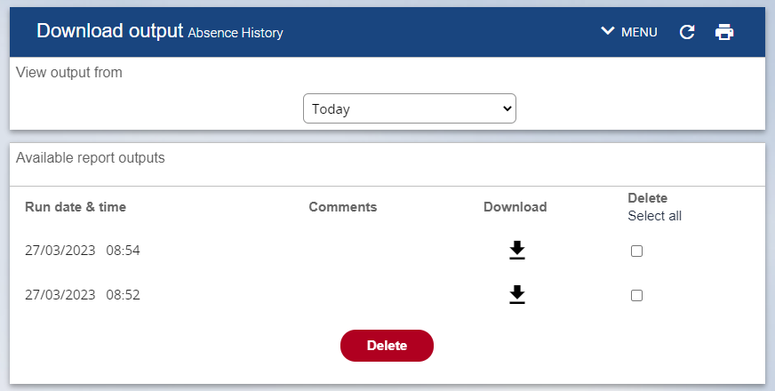

1. Your windows system may then display a message box asking you if you want to open or save the file

Image of windows open or save download message



1. Click open to view the report

